Single Audit File for Tax
JPK 3.7(007) update instructions
Version date: 08.10.2025

Table of contents

1 General information 3
1.1 How to check JPK version 3
1.2 How to check SAP_ABA component version 3
1.3 OneAPI description 4
1.4 Import instructions 5
2 Transport Order ECC 6
3 Transport Order S4Hana / Simple finance 6
4 Changelog 7

General information
- JPK version 3.5(004) (required). How to check JPK Version
- OneAPI in version 1.0(005) (recommend) OneAPI description
- In ECC check SAP_ABA component version and select proper transport list. How to check SAP_ABA version.

How to check JPK version
- Go to /n/BCC/JPK transaction
- Select About application
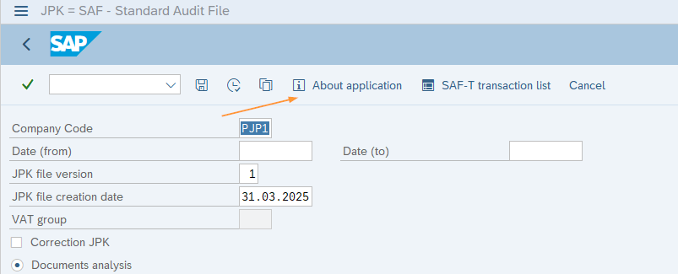

How to check SAP_ABA component version
- Check only in ECC. S4Hana / Simple Finance has sperate transports.
- Select System -> Status
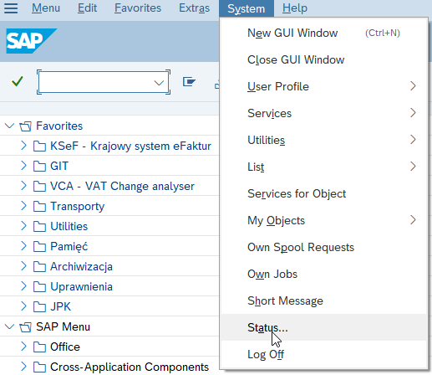

- Select Details
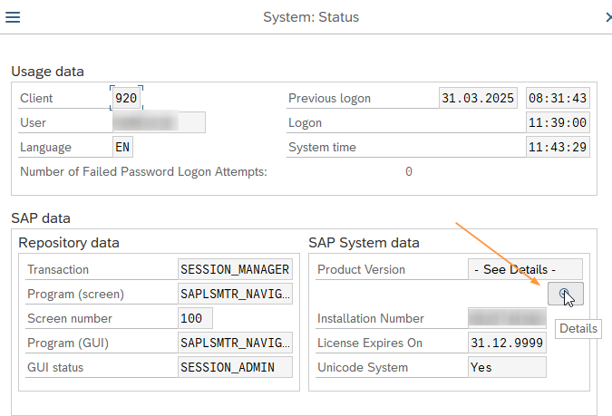
- Go to Installed Software component version and find SAP_ABA component. If version is below 702 then use transports for SAP_ABA < 7.02.
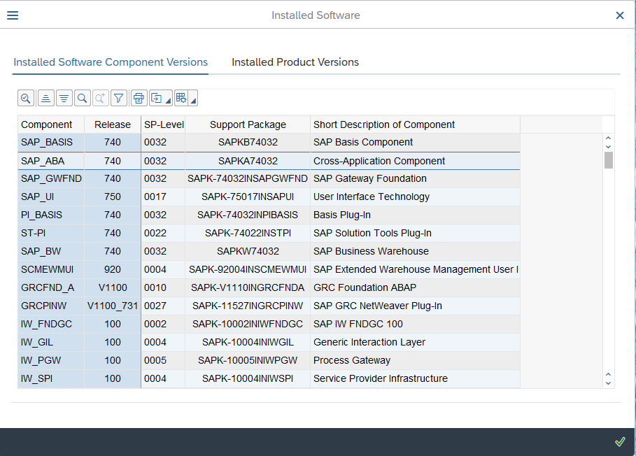

OneAPI description
OneAPI is All for One Poland’s component which includes methods and customizing used in various All For One Poland’s financial products. All OneAPI objects are created in namespace /BCCOA/. OneAPI is not mandatory for JPK, but it is highly recommended. OneAPI contains for example the customizing of customers’ VAT groups, display of full JPK transaction list, export of JPK customizing and enhancement to CSV and text files.
JPK requires OneAPI in minimal version 1.0(005).
How to check the OneAPI version.
- Go to /n/BCCOA/HOME (if transaction doesn’t exit it means that OneAPI is not installed).
- Select About
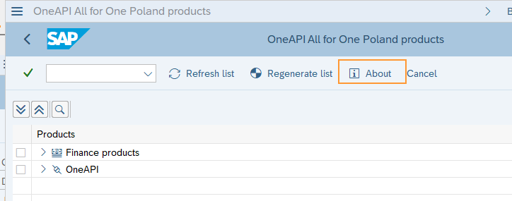
- Find ONEAPI product and its version on the list
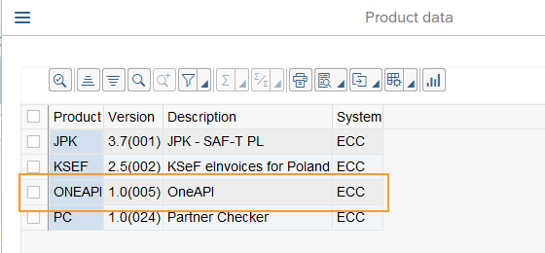

Import instructions
- All objects are in /BCC/ and /BCCOA/ (OneAPI) namespaces. It may be required to add these namespaces in SAP when using Solman.
- While importing transport select Ignore Invalid Component Version (if available) and select Target Client for Customizing transport. JPK source client in All For One SAP is 920.
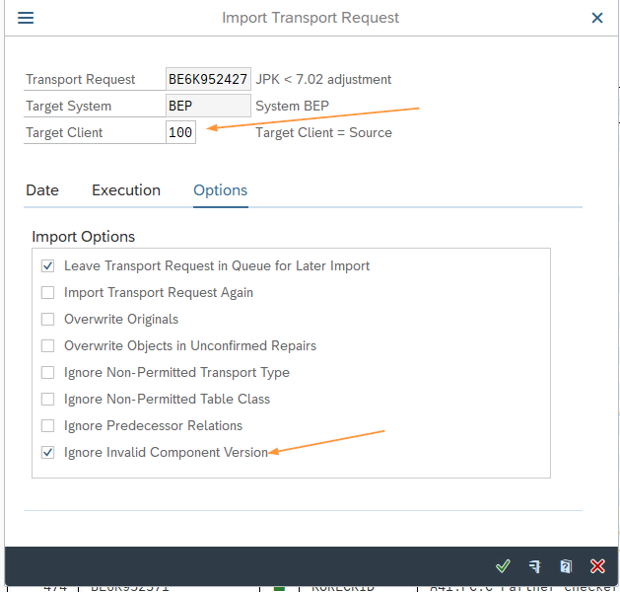

Transport Order ECC
For ECC remember to check SAP_ABA version.
Order | ECC SAP_ABA >= 7.02 | ECC SAP_ABA < 7.02 | Type | Description
1 | BEPK912810 |  | Workbench | (OPTIONAL) OneAPI. Import only if OneAPI is not installed or is below version 1.0(005). Check the OneAPI description.
2 | BEPK912811 |  | Customizing
3 | BEPK913651 | BEPK913650 | Workbench | JPK 3.7(007) update
4 | BEPK913652 |  | Customizing | JPK 3.7(007) update

Transport Order S4Hana / Simple finance
Simple finance (SFIN/CFIN) has different workbench transport.
Original system for S4Hana and Simple Finance transports is BWM.
Order | S4Hana | Simple Finance | Type | Description
1 | BEPK912810 |  | Workbench | (OPTIONAL) OneAPI. Import only if OneAPI is not installed or is below version 1.0(005). Check the OneAPI description.
2 | BEPK912811 |  | Customizing
3 | BWMK901395 | BWMK901396 | Workbench | JPK 3.7(007) update
4 | BWMK901397 |  | Customizing | JPK 3.7(007) update

Changelog
Date | Person responsible | Comment
30.06.2025 | Dominik Korecki | Updated transport list
03.04.2025 | Dominik Korecki | Updated S4Hana/Simple Finance transport list
02.04.2025 | Dominik Korecki | Updated ECC transport numbers. Old transport included usage of /BCCKSEF/ object which may result in errors on systems without KSeF.
31.03.2025 | Dominik Korecki | Created

